**User unable to login**

Case-1:-user successful login

Log file :- /var/log/secure

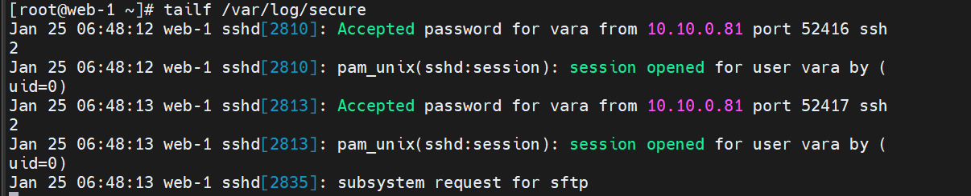

Log file: - /var/log/messages

No logs are generated in this file

Case-2:- if user enters wrong password

ERROR

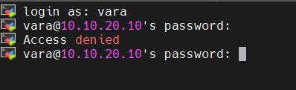

Log file: - /var/log/secure



Log file: - /var/log/messages

==== No logs are generated in this file

Case-3:- enters wrong user name

ERROR:

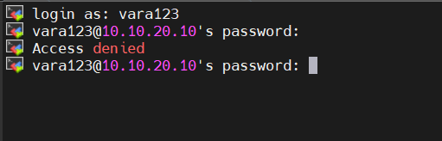

Log file: - /var/log/secure

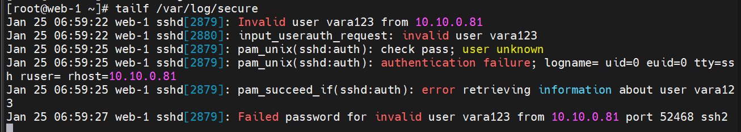

No Logs Are Generated in /var/log/messages

Case-4: -user password is locked

ERROR:

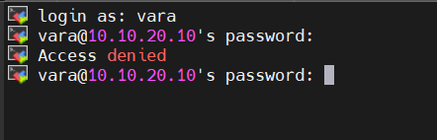

Log file: /var/log/secure



NO Log files are generated in /var/log/messages

Case-5:- sudo user execute commands

User=vara

Log file: /var/log/secure



NO logs are generated in /var/log/messages

Case-6:- reboot the server with sudo user

/var/log/secure

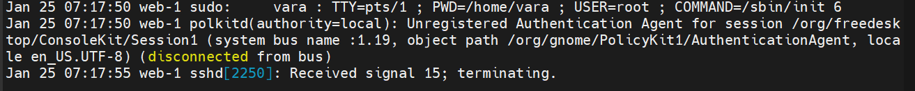

/var/log/messages

